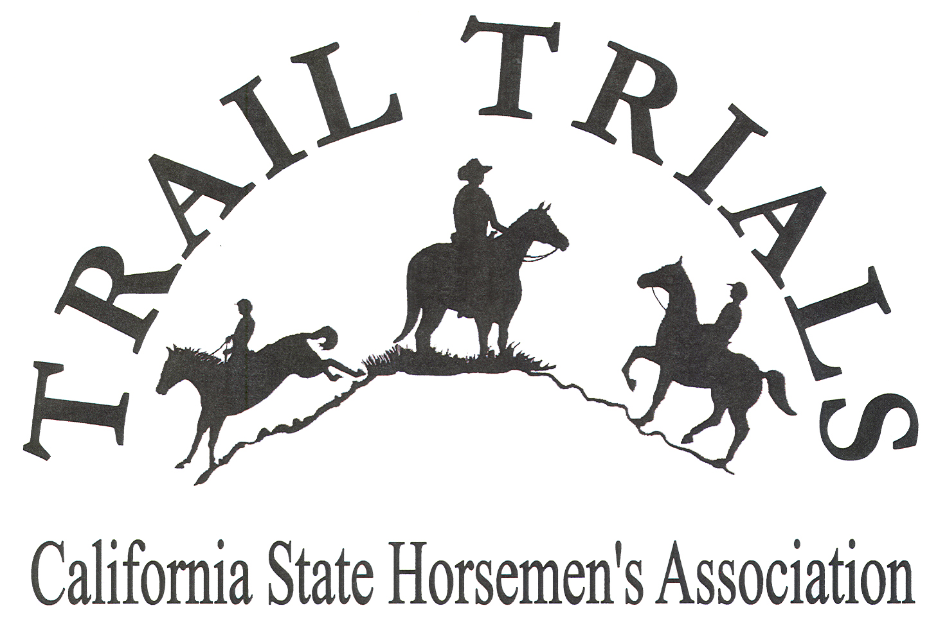
CSHA Region ____
Trail Trials Program Registration
2019

Date__________________(CSHA membership required, ride credit not given prior to this date)

Enrollment for the Region program consists of one horse, one rider combination. The same horse and the same rider every time is your team. A team must compete at three (3) sanctioned Trail Trials in the same category and division and be a member of the Region Trail Trials Program to qualify for the State Championship Event. Program members must be members of CSHA at time of point/credit accrual, no retroactive points/credit. You must also work at least one trail trial event to be eligible to enter the State Championship Event (Trail Trials Rule 9.4.3) as verified by your Region Chair.

Name_________________________________________Email______________________________

Address________________________________________City____________________Zip________

Phone_______________________________________

Horse’s Name_______________________________________Breed_________________________

Circle One: Mare Gelding Stallion Color______________________________________

There are three categories based on your team’s capabilities circle one:

Novice: Horse or rider is not experienced or not comfortable with advanced trails or obstacles.
Intermediate: Team completes approximately 50% of obstacles novice and 50% advanced.
Advanced: Horse and rider are comfortable with advanced trails and advanced obstacles.

Rider Age Division circle one: 17 & under 18-49 50-59 60 and over
Your age as January 1 of the current ride year (1-1-19): _______ Birthdate: ______________________

Region Program Fee: $________(Region award requirement or Fee may differ from State requirement)

You must ride a minimum of three rides and fulfill your one event work obligation. Trail trial ride year is from the third weekend in September through the second weekend in September the following year.

I am a: ⁭ Direct CSHA Member ⁭ Member of CSHA Club named_______________________

Submit check and form to: CSHA Region___ Trail Trails
(Chair name and address here)

This section for Chair Use Only:
Region Chair Name and Membership Verification Date:____________________________________
Mail copy to (no ride status credit given until received): Diane Medlock, 41929 County Road 27,Woodland, CA 95776

